**Moving Enemies with timeline**

**Objective:** In this lesson students are going to apply their knowledge of the Timeline to move an enemy spaceship across the map.

1. Set **slider** to **3 seconds**
2. Create a **Sphere** GameObject **slightly in front** of the Player Ships current coordinates. **Scale** it up to **20x20x20**
3. Drag the **Sphere** from the **Hierarchy** down to the Timeline Animation Track and Select **Add** **Animation Track**.
4. Click **Record** and Jiggle the Sphere
   * Alternatively you could have right click the position for the Sphere in the Inspector and click **update key**

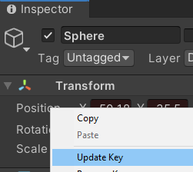

1. Move slider to 1 second and move the enemy ship a bit off the path
2. Move slider to 0 seconds and move enemy ship off screen. Maybe even off the map.
3. Move slider to 5 seconds and move ship further along its path AFTER the interaction
4. Stop Recording and click Play to see the two movements. Make sure to click **Game** screen tab and click **play** to see it better.
5. If you want to edit the movement Right Click the Sphere timeline and select **Edit in Animation Window**

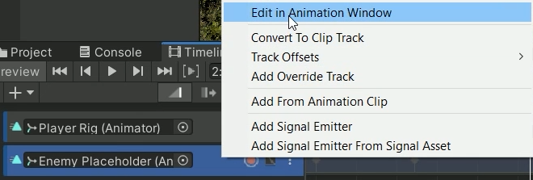

1. If you want to change the speed of your enemy you can **select all points** and use the **blue bars** to shorten/increase the time it takes to reach these points.



1. You can even move the time the sphere is at a certain position by **dragging the top marker** left/right
2. If you want to change the rotation/position of the enemy go to the timeline tab and select the Graph icon



1. expand the Position property

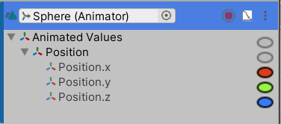

1. For instance at this moment I want my enemy to dip

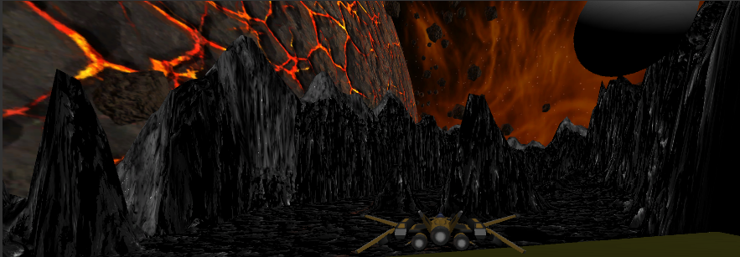

1. In my timeline I can decrease the y graph (green) at this specific moment in time to make it dip down. Rotation would have been an option if I had changed its rotation.
2. If I ever want to add another moment I can move the slider to that moment, right click and select Add Key. Then I can change the position/rotation at that moment.
3. There’s also handles on either side of a key frame so you can change the curve of the graph

